SIMATS ENGINEERING
ASSESSMENT TOOL III – VISUALIZATION CRITIQUE & REDESIGN
Course: Data Handling and Visualization | Code: DSA0601 | CO: CO3
Duration: 120 min | Total Marks: 100 | Reg No:
Name:

COURSE OUTCOME COVERED
CO3: Analyze time-series data, trends, associations, and uncertainty through appropriate visualization methods. (BL4) Activity Tool: Visualization Critique & Redesign Weightage: 20%
Code of Conduct:
I V.P Sneha(192324284) (Name / Reg No) certify that this submission is my original work and that I have adhered to the guidelines specified for this assessment. I understand that any violation of academic integrity rules will result in disciplinary action.
Signature of the student: _v.p sneha_____________________________
Criteria | Evaluation of Existing  Visualization  (25%) | Redesign  Strategy  (25%) | Application of Vis. Principles (20%) | Organization (15%) | Accuracy (10%) | Clarity  (5%) | Total
Q1
Q2
Q3
Q4
Q5

AT3 – Visualization Critique & Redesign
R Programming Assessment – Distribution and Proportion Visualization
Instructions: For each question, use R/RStudio to reproduce the given visualization, critique its effectiveness, identify misleading or inappropriate visual encodings, and redesign it using a more suitable visualization. Include the R code, redesigned visualization, and a concise justification of your design decisions.
Question 1 – Critique and Redesign an ECDF and Q-Q Plot
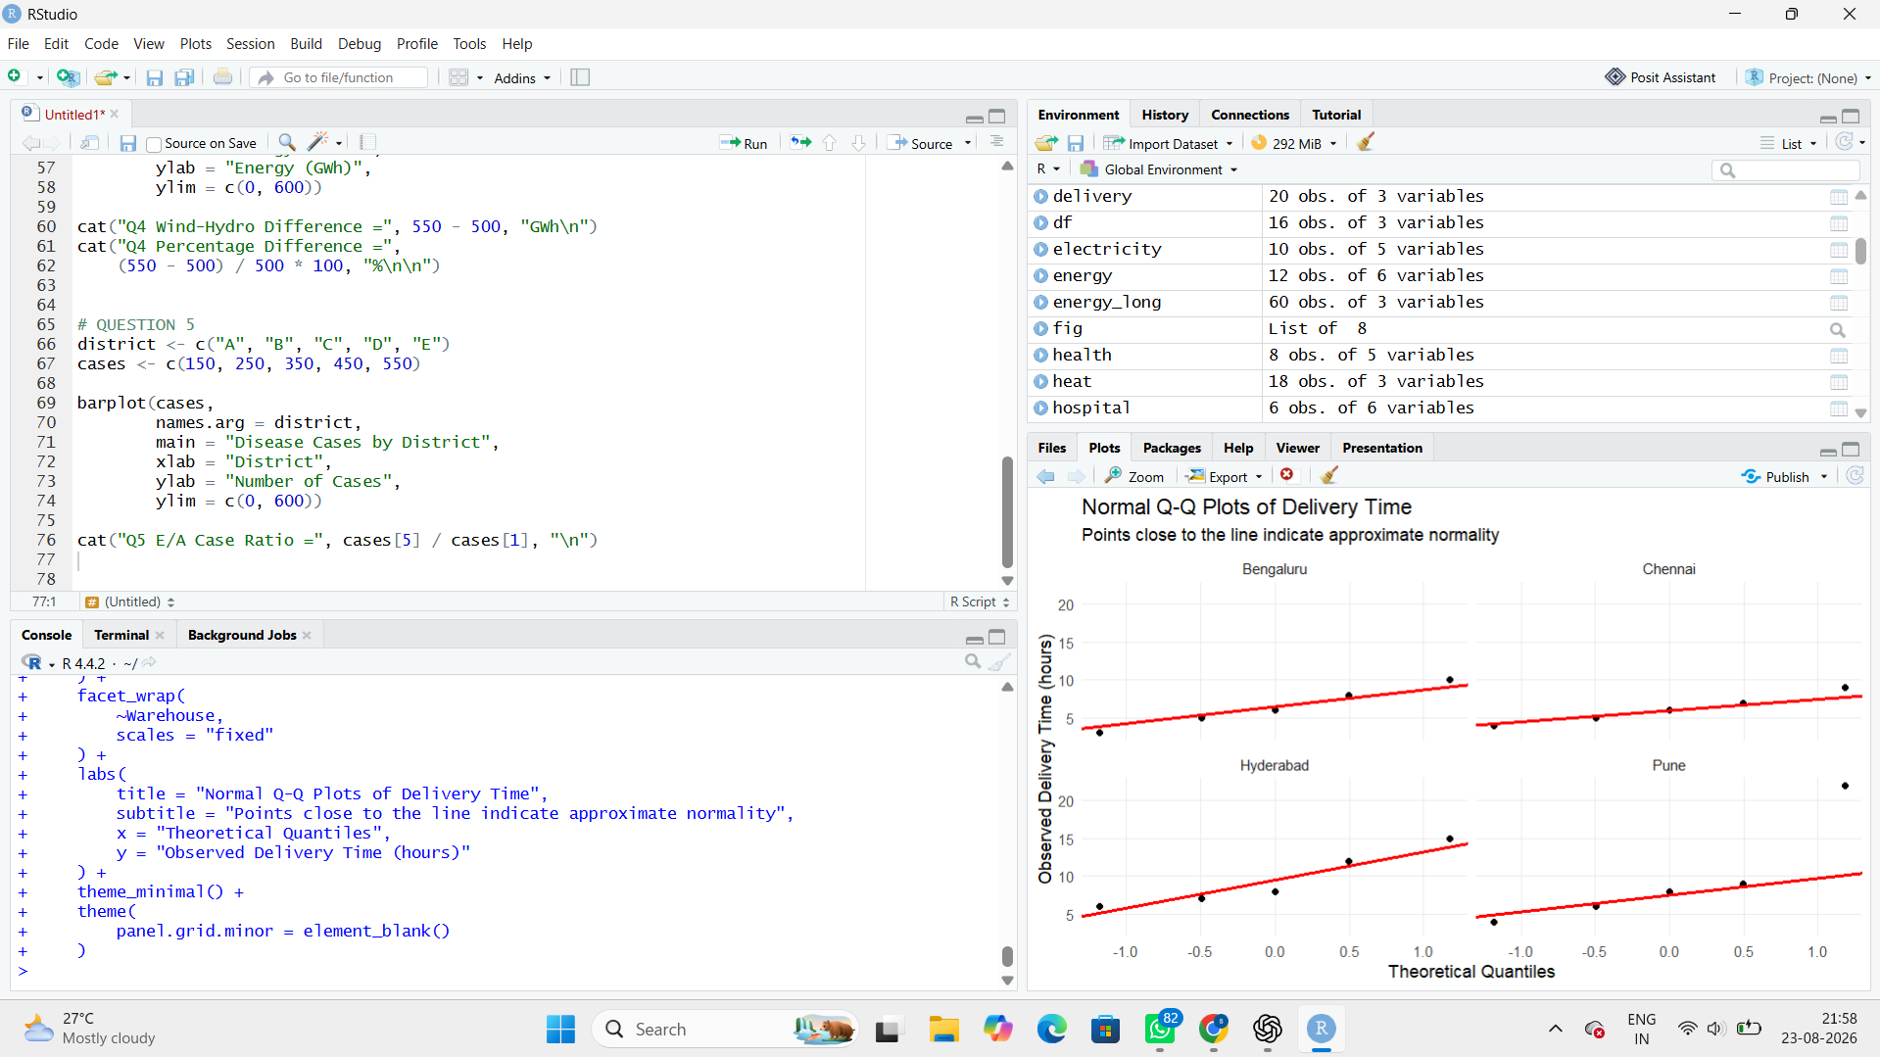

Problems in the original visualization
At least three problems are:
- Inconsistent axis scaling makes warehouse comparisons difficult.
- Missing Q-Q reference line makes normality assessment harder.
- Excessive gridlines create visual clutter.
- Labels are not sufficiently clear.
- The extreme value of 22 hours in Pune may be difficult to identify without appropriate scaling.

Interpretation
Pune has a clear high delivery-time observation of 22 hours, suggesting a possible outlier/right-tail observation.
The Q-Q plot helps determine whether the data follow a normal distribution. Strong deviations from the reference line indicate non-normality.

Is ECDF alone sufficient?
No.
An ECDF is useful for comparing distributions and identifying unusual tail behavior, but it should be paired with a Q-Q plot, boxplot, or another diagnostic plot to investigate outliers and normality more clearly.

Question 2 – Critique and Redesign Many Distributions Using Bean Plots
Dataset: Subject_Marks.csv
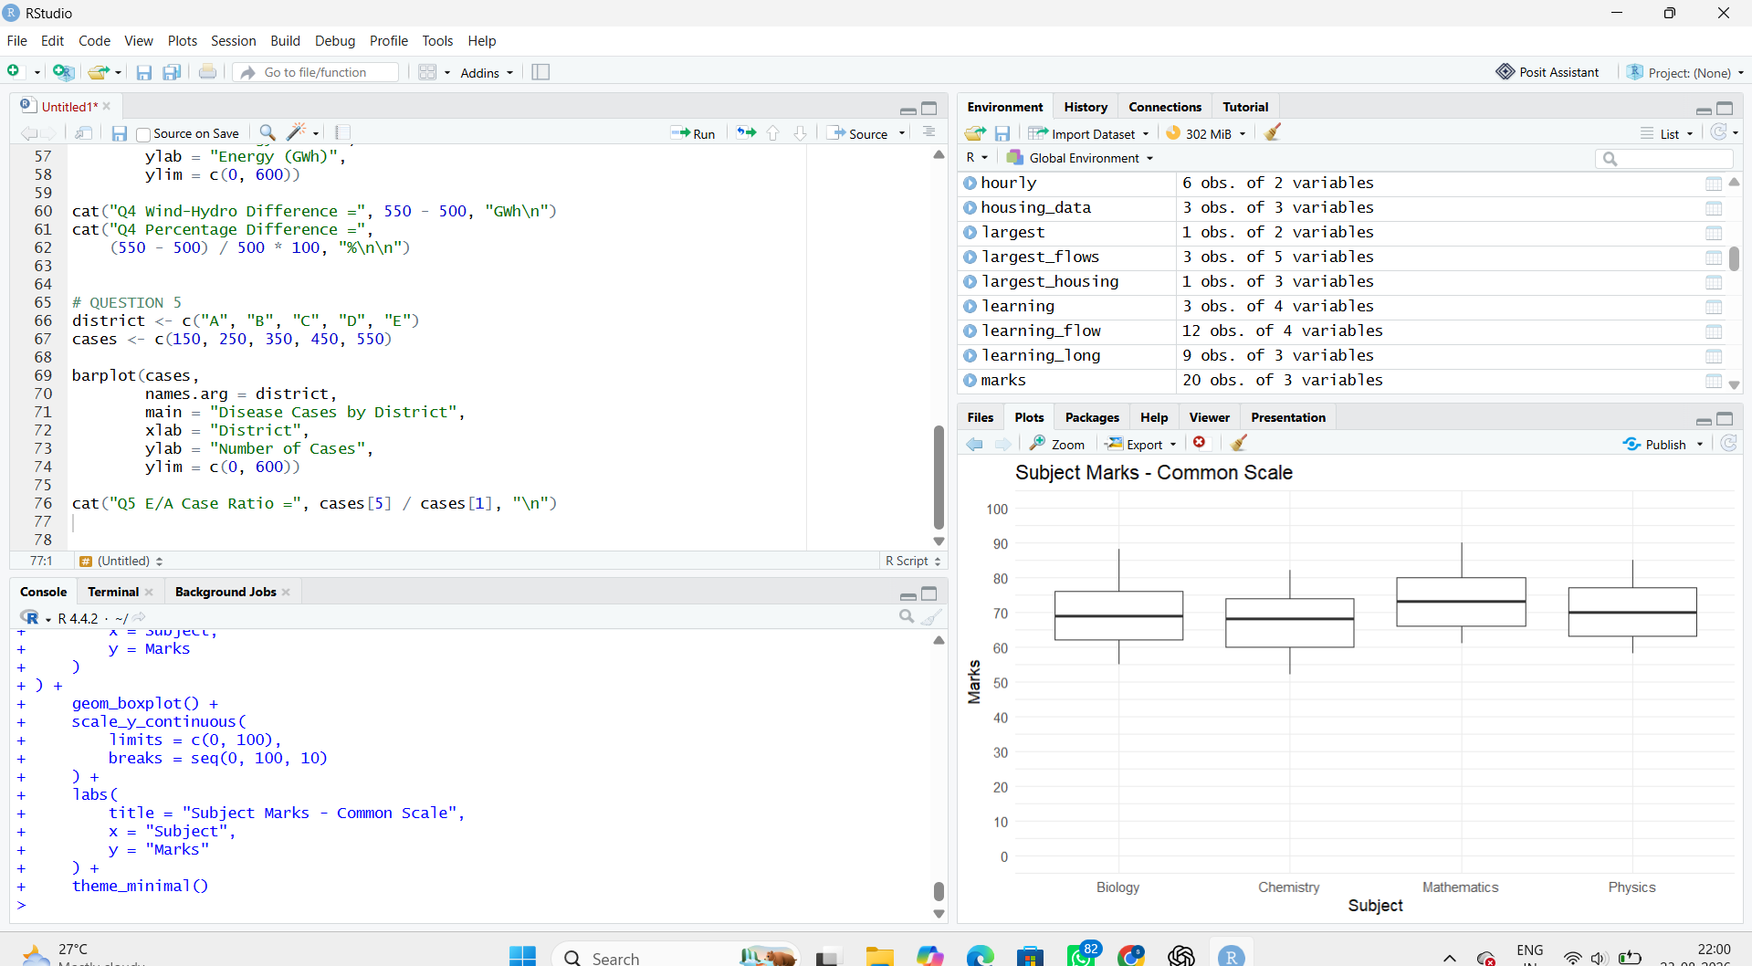

Problems
The original visualization has:
- Different Y-axis ranges.
- Separate layouts.
- Difficult direct comparison.
- Potentially truncated axes.
- Different visual scales can exaggerate small differences.

Highest concentration
Chemistry has a relatively concentrated and regular distribution.

Greatest spread
Compare ranges:
- Physics = 85 − 58 = 27
- Chemistry = 82 − 52 = 30
- Mathematics = 90 − 61 = 29
- Biology = 88 − 55 = 33
Therefore:
Biology has the greatest range/spread = 33 marks.
A common Y-axis from 0–100 makes comparisons more honest.

Question 3 – Critique and Redesign Proportion Visualizations
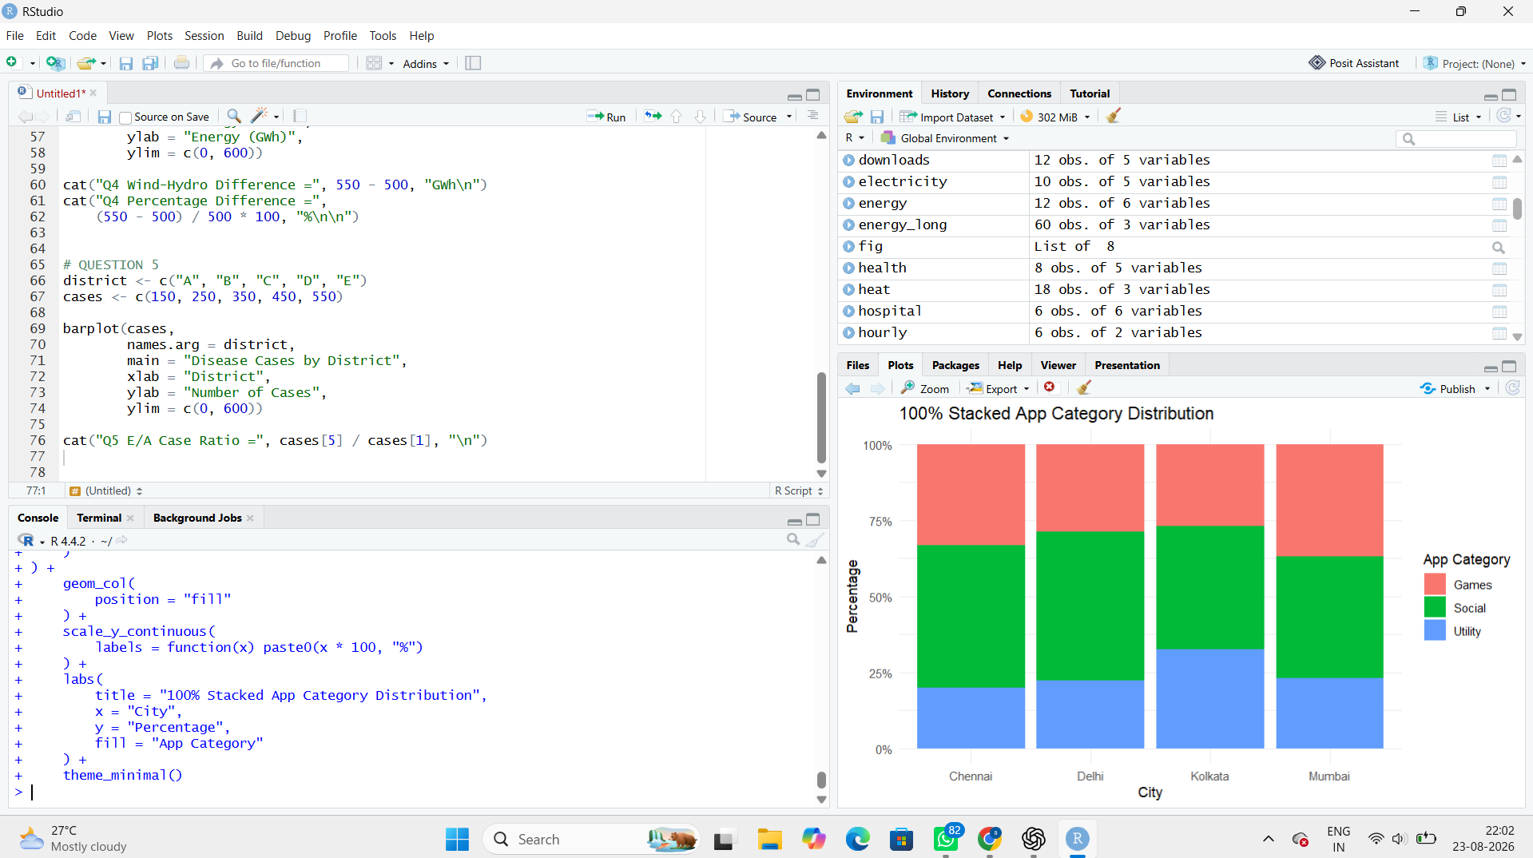

Four problems with the pie charts
- Exploded slices exaggerate visual importance.
- Mismatched colors make the same category difficult to track across cities.
- Pie slices are difficult to compare accurately.
- Inconsistent labeling creates confusion.
- Comparing angles and areas is less accurate than comparing bar lengths.

Better chart
For comparing city-wise proportions, the side-by-side bar chart is generally better because all categories share a common baseline.
The 100% stacked bar is better for showing the overall composition of each city.
Question 4 – Critique and Redesign Nested Proportions
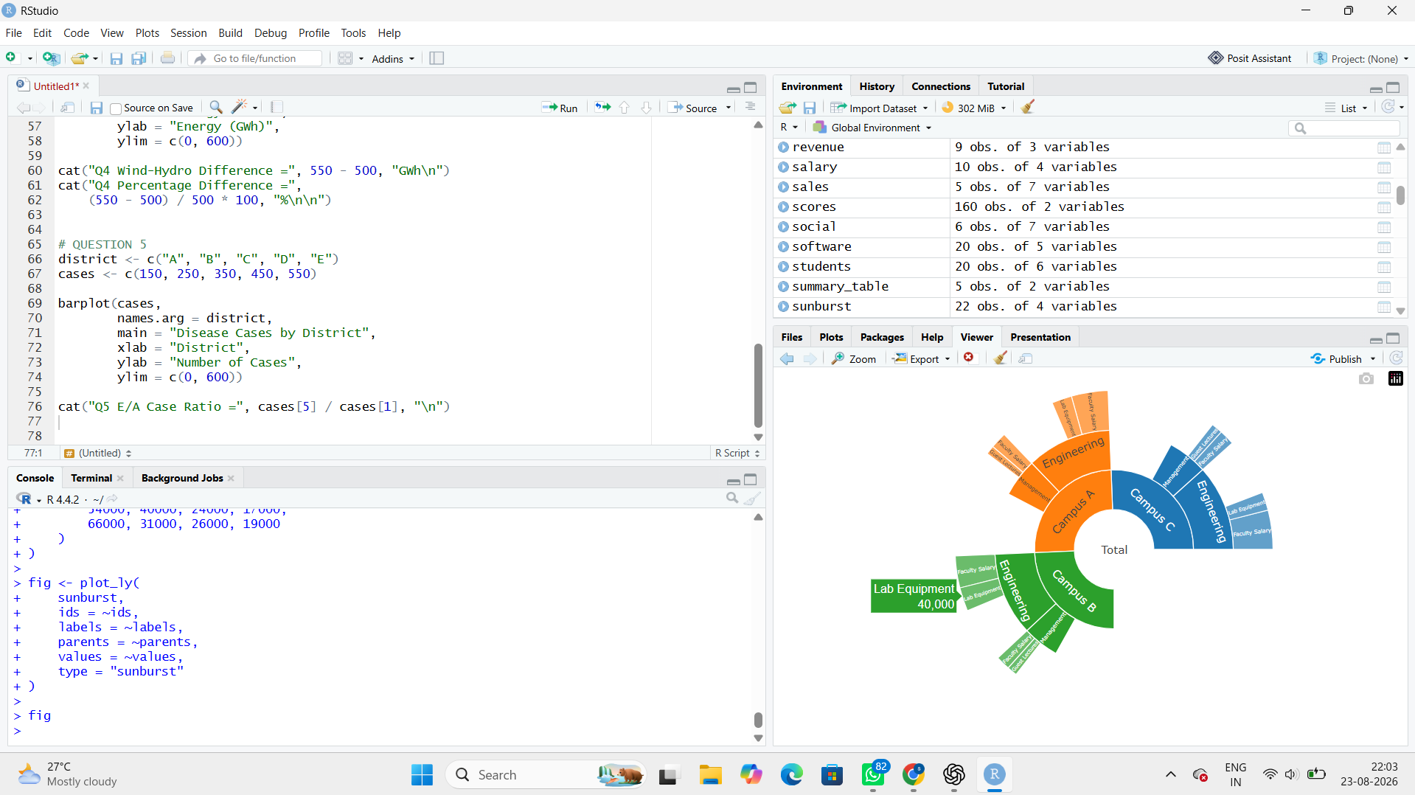

Critique
Problems with the original treemap:
- Small areas have unreadable labels.
- Colors do not clearly communicate hierarchy.
- Department and expense type can be difficult to distinguish.
- Too much information is displayed at once.
- Small rectangles are difficult to compare.

Board presentation recommendation
I recommend the redesigned treemap for a board presentation because it gives a quick view of spending magnitude and allows categories to be compared visually.
The sunburst is better when the main purpose is explaining the hierarchy:
Campus → Department → Expense Type.
Question 5 – Critique and Redesign Flow-Based Proportions
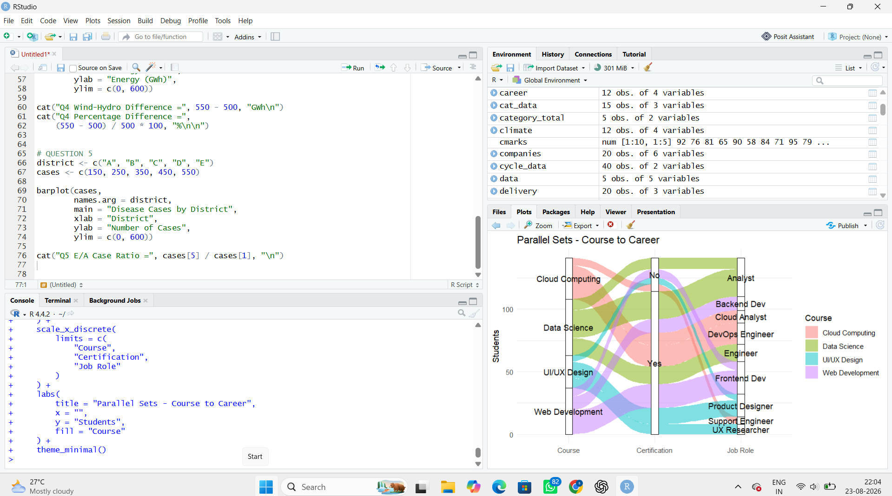

Four possible problems in the original Sankey
- Near-identical colors make flows difficult to distinguish.
- Unlabelled flows make the exact meaning difficult to understand.
- Inconsistent node widths can distort perceived flow magnitude.
- Small flows may be difficult to see.
- Poor ordering can cause excessive crossing of links.
- Lack of numerical labels makes exact comparison difficult.

Redesign improvements
The redesigned chart should use:
- Clear node labels.
- Meaningful colors.
- Consistent flow widths.
- Clear hierarchy.
- Course → Certification → Job Role ordering.
- Minimal unnecessary decoration.

Major career flows
The largest individual flow is:
Data Science → Yes → Analyst = 22 students
Other major flows include:
Web Development → Yes → Frontend Dev = 19
Cloud Computing → Yes → DevOps Engineer = 17

